An allele-selective target-site atlas for ATXN1
Stanislaw Adaszewski (https://stanislawadaszewski.com)
Oct 4, 2026
Draft manuscript.

Abstract
Spinocerebellar ataxia type 1 (SCA1) is caused by a CAG repeat expansion in one copy of ATXN1, and the wild-type copy appears protective, so therapies that lower both copies carry on-target risk. The discrimination axis used by the only clinical-stage agent — repeat length — is documented to fail at ATXN1, because wild-type alleles already carry ~29–30 repeats. Single-nucleotide variants offer an orthogonal axis, and for HTT they underpin three published allele-selective target-site resources. No equivalent exists for ATXN1.
We built one. Screening 24,701 biallelic SNVs across ATXN1 ±200 kb in 2,504 phased 1000 Genomes samples against four CRISPR nucleases on both strands, we identify 613 variants that create or destroy an SpCas9 NGG PAM within the gene, and 85 that exceed 30% heterozygosity in all five superpopulations. Run blind over HTT, the same pipeline recovers rs363099 and reproduces its published eligibility (19.7% vs ~20% reported), calibrating the method.
ATXN1 exceeds HTT on every measure: 613 versus 197 PAM-altering sites, and 99.8% versus 78.1% of European-ancestry individuals for whom a selective guide is guaranteed to exist whichever haplotype carries the expansion. Six guides cover 98% of individuals in every ancestry group. Because no haplotype profile exceeds 0.76% of chromosomes across the 462 kb locus, this conclusion is robust to founder structure: under a maximally adversarial single-founder model the eligibility floor is 96.46% across all 26 populations. Repeating the entire analysis on the 1000 Genomes 30× high-coverage callset, on GRCh38, leaves every one of these figures unchanged.
Finally, rs2075974 — the only ATXN1 variant with a published association to expanded chromosomes — is itself PAM-creating, 537 bp from the repeat, with the disease-associated allele generating the PAM.

Introduction
The case for allele-selective ATXN1 lowering has been made twice in print, and the genomics that would enable it has never been done.
SCA1 is a dominantly inherited, progressively fatal cerebellar ataxia caused by expansion of a CAG tract in ATXN1 beyond ~39 repeats [1]. The expanded allele produces a polyglutamine-expanded ataxin-1 protein that is toxic to cerebellar Purkinje neurons. Because the disorder is dominant, patients retain one structurally normal copy.
That normal copy is not inert. In knock-in mice, disrupting phosphorylation at ataxin-1 S776 on the expanded allele alone rescued motor coordination, breathing and lifespan, whereas disrupting it on both alleles gave an attenuated rescue — evidence of a protective role for the wild-type allele [2]. Independently, an unbiased genomic characterisation of the polyglutamine disorder genes ranked ATXN1 among four genes (with ATN1, ATXN7 and HTT) scoring unfavourably on all three features associated with clinical-trial stoppage for safety: genetic constraint, broad expression and many protein interactors. ATXN1 was the most pleiotropic gene in that analysis, with 57 significant trait associations, and alleles lowering ATXN1 expression tracked with lower educational attainment and cognitive ability. The authors recommended allele-selective approaches explicitly [3].
The field's response has been to pursue repeat length as the discriminating feature, on the logic that a longer tract offers more binding sites. That logic is sound at HTT, where normal alleles carry ~17 repeats against 45 or more on expanded alleles. It is not sound at ATXN1. Hu and Corey tested it directly and could not achieve allele-selective inhibition, attributing the failure to the high wild-type repeat number: ~29–30 repeats already supports three to four cooperative anti-CAG interactions, leaving "poor discrimination between the mutant and wild-type repeat" [4]. The two CAT interruptions in the wild-type tract may further disrupt the structure that repeat-directed agents recognise. Yet VO659, the only clinical-stage agent covering SCA1 (NCT05822908), discriminates on exactly this axis, and every selectivity figure published for it concerns HTT rather than ATXN1.
Single-nucleotide variants provide an orthogonal and binary axis. Where a patient is heterozygous, their two ATXN1 copies differ by an actual base, and an agent can be designed against one and not the other. For CRISPR the sharpest form of this is a variant inside the PAM: SpCas9 requires an NGG motif adjacent to the protospacer and physically cannot cut without it, so a PAM-altering variant confers mechanical rather than merely preferential selectivity [5].
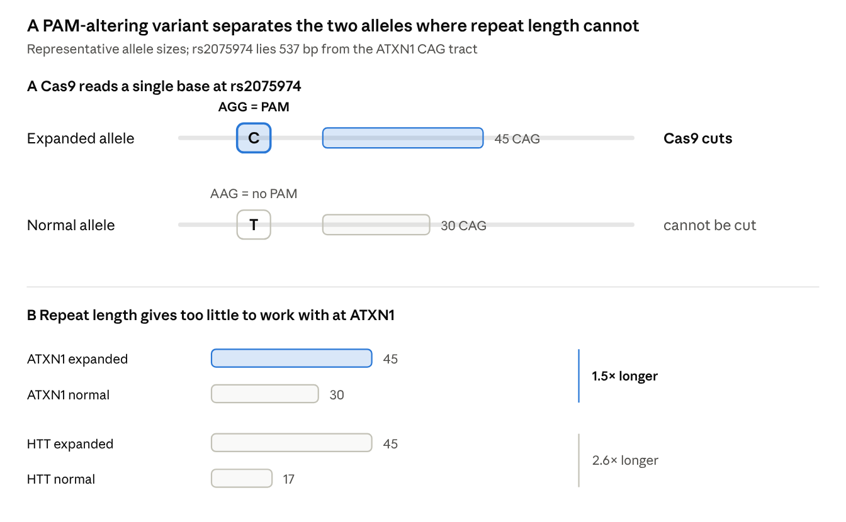
Figure 2 · the two discrimination axes, drawn at representative allele sizes
A PAM is present or absent; repeat length is a matter of degree, and at ATXN1 the degree is small.
This approach is mature at HTT. Warby et al. showed that 95% of European HD chromosomes carry a single haplogroup, making a small target panel viable [6]; Kay et al. built prioritised haplotype target panels from 2,364 patient haplotypes [7]; Shin et al. catalogued 230 PAM-generating alleles across HTT and reported 72.5% cumulative eligibility for European-ancestry patients [8], having shown that rs363099 eliminates the NGG PAM on the commonest normal haplotype in ~20% of them [9]. AlleleAnalyzer generalised the method to 11 Cas proteins genome-wide [10].
For ATXN1, none of this exists. A PubMed query for ATXN1 with haplogroup, predisposing haplotype or cis-element returns no records. The current SCA1 therapy review names SNP-directed allele-selective silencing as the desirable strategy and, at that sentence, can cite only ATXN3 and ATXN7 work [11]. The ATXN1 haplotype literature comprises roughly eight studies, almost all 1990s microsatellite analyses with two to four markers spanning ~1.2 Mb in cohorts of 6 to 134 probands — too coarse and too distant from the repeat for target selection.
Here we build the missing resource, validate the pipeline against the HTT benchmark, and test whether the conclusion survives the obvious objection that SCA1 founder effects might concentrate disease chromosomes onto backgrounds that resist discrimination.

A PAM-altering variant atlas across ATXN1
The ATXN1 locus is densely polymorphic: 24,701 analysable biallelic SNVs lie within the gene and its 200 kb flanks, and 23,990 of them alter a PAM for at least one of four nucleases.
We took chr6:16,099,343–16,961,691 (GRCh37), spanning ATXN1 (chr6:16,299,343–16,761,691, minus strand, 462,349 bp) plus 200 kb on each side. The region contains 25,771 records in the 1000 Genomes Phase 3 callset, of which 24,706 are biallelic single-nucleotide variants. Four sites exceeded the Hardy–Weinberg ceiling of 50% observed heterozygosity — the highest reaching 77.2%, which is genetically impossible and marks a collapsed paralogue — and were removed along with one further site showing excess-heterozygosity z > 8, leaving 24,701.
Every REF allele in the retained set matched the independently retrieved GRCh37 reference sequence (24,701/24,701), confirming the build and coordinate frame.
For each variant we tested, on both strands, whether substituting the alternative allele creates or destroys a PAM motif in any window overlapping that position, for SpCas9 (NGG), SaCas9 (NNGRRT), xCas9/SpCas9-NG (NG) and Cas12a (TTTV).
Nuclease | PAM | Altering | Created | Destroyed
SpCas9 | NGG | 9,247 | 3,251 | 6,156
SaCas9 | NNGRRT | 3,598 | 1,775 | 1,984
xCas9 / SpCas9-NG | NG | 23,251 | 10,395 | 14,950
Cas12a | TTTV | 3,771 | 2,478 | 2,082
Any of the four | — | 23,990 | — | —
Counts cover the full 862 kb window. Created and destroyed are not mutually exclusive: a single variant can create one PAM and destroy another at a different offset or on the other strand.
Restricting to the gene body, which is what matters for a transcript-directed therapy, 613 variants alter an SpCas9 PAM at ≥2% heterozygosity. The practically relevant subset is larger than the raw count suggests: 257 in-gene SpCas9 sites exceed 20% heterozygosity overall, 170 exceed 30%, and 124 exceed 20% in every one of the five superpopulations.
We also located the CAG tract directly in the retrieved reference, without recourse to an annotation file. The plus strand at chr6:16,327,867–16,327,953 reads CTG×14 · ATG · CTG · ATG · CTG×12, which on the minus strand is the CAG tract carrying two CAT (histidine) interruptions — the canonical configuration of a normal allele, interruptions being present in ~98% of unexpanded chromosomes [12]. This independently fixes the repeat position used for the distance calculations below.
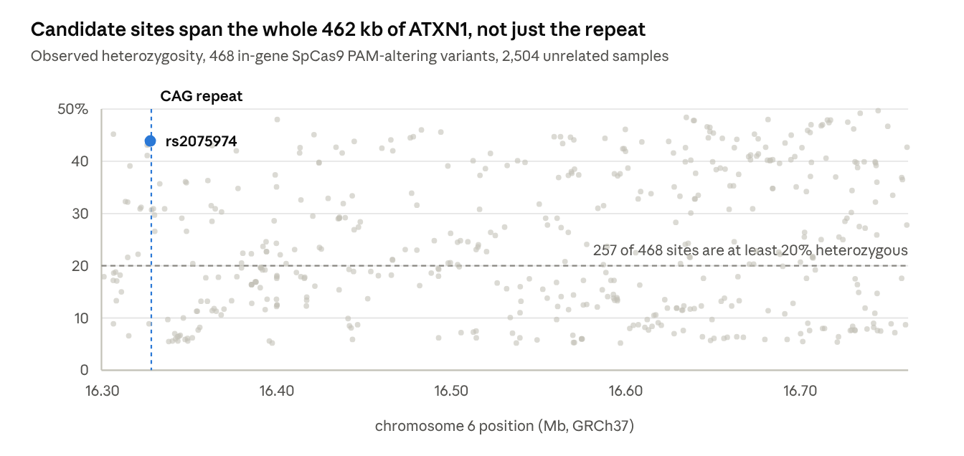
Figure 1 · 468 in-gene SpCas9 PAM-altering sites, 1000 Genomes Phase 3, GRCh37
Candidate sites are spread across the locus rather than clustered near the repeat, which is what makes the panel in the next section small and what limits the reach of any founder effect.

Validation against the HTT benchmark
Run without modification over HTT, the pipeline recovers the published allele-selective site and reproduces its reported eligibility to within 0.3 percentage points.
We applied identical code to chr4:3,076,408–3,245,687 (GRCh37), the HTT gene body, with no parameter changes and no knowledge of the expected answer encoded anywhere in the screen. It returned 197 SpCas9 PAM-altering variants at ≥2% heterozygosity, among them rs363099 at chr4:3,162,056.
The call is correct at the sequence level. The reference C allele gives CCG on the plus strand, which reads CGG on the minus strand and is a valid NGG PAM; the alternative T gives TCG, reading CGA, which is not. The variant therefore destroys the PAM, matching the published description [9].
 | Value
Position (GRCh37) | chr4:3,162,056
Change | C>T
Effect | destroys NGG, minus strand
Observed heterozygosity, EUR | 39.4%
× P(favourable phase) = 0.5 | 19.7%
Published estimate [9] | ~20%
The agreement also settles what the published figure means operationally. Eligibility at a single PAM-altering site is the product of two independent quantities: the chance a patient is heterozygous there, and the chance the PAM-bearing allele happens to lie on the expanded rather than the normal chromosome. Absent prior knowledge the second is 0.5. Shin et al. reached ~20% from common diplotypes and 23.1% from counting patients heterozygous at rs363099 who also carry the relevant normal haplotype [9]; our 19.7% from heterozygosity alone falls in the same place. We adopt this het × ½ convention for single-site estimates throughout, and depart from it only where phase is independently known.
Two further checks support the screen. Reference-allele concordance was complete at both loci. And at the variant that matters most in the ATXN1 results below, the Phase 3 alternative-allele frequency (0.369) agrees with the independent 30× high-coverage callset (0.365) to within 0.004, indicating that the low coverage of Phase 3 does not materially affect common-variant genotypes at this locus.

ATXN1 is a more tractable allele-selective target than HTT
On the same method, ATXN1 offers three times as many PAM-altering sites as HTT and a substantially higher fraction of patients for whom a selective guide exists.
Measure (SpCas9 NGG) | HTT | ATXN1
Gene length | 169 kb | 462 kb
PAM-altering SNVs, het ≥2% | 197 | 613
Best single-site heterozygosity, EUR | 49.1% | 55.1%
Best single-site heterozygosity, any ancestry | 52.3% (SAS) | 55.1% (EUR)
Heterozygous at ≥1 PAM-altering site, EUR | 92.2% | 100.0%
Heterozygous at ≥1 PAM-altering site, all | 92.2% | 99.8%
Phase-agnostic eligibility, EUR | 78.1% | 99.8%
Phase-agnostic eligibility, all | 81.0% | 99.6%
Both columns were produced by one script in one run, over the same 2,504 samples, with the same filters and the same PAM logic. The comparison is therefore internal and not assembled from differently derived published figures.

Phase-agnostic eligibility
The honest difficulty with any SNP-based approach is that population data cannot say which of a patient's chromosomes carries the expansion. Reporting heterozygosity alone overstates what is deliverable, because half of heterozygous patients would, at any given site, have the PAM on their healthy copy.
We therefore define phase-agnostic eligibility: the fraction of individuals for whom a usable guide is guaranteed to exist whichever haplotype carries the expansion. Formally, using the phased haplotypes, we ask whether both haplotypes are independently targetable — whether there is at least one heterozygous site where haplotype 1 carries the PAM-bearing allele, and at least one (not necessarily the same) where haplotype 2 does. If both hold, then once that patient's phase is resolved by a clinical assay, a selective guide is available regardless of the answer.
This measure assumes nothing about phase and so cannot overstate eligibility on that account. It is the number we propose for comparing loci. At ATXN1 it is 99.6% overall and 99.8% in European-ancestry individuals; at HTT, run identically, 81.0% and 78.1%.
The structural reason is straightforward. ATXN1 is 2.7 times longer than HTT and comparably polymorphic, so it carries roughly three times as many candidate sites distributed across more recombination distance. A patient's two ATXN1 chromosomes differ somewhere useful almost without exception.

Six guides cover 98% of individuals
A panel of six PAM-altering sites leaves no ancestry group below 96.8% coverage, and the first site alone covers half of all individuals.
We applied a greedy set cover over the 468 in-gene SpCas9 PAM-altering sites with ≥5% heterozygosity, selecting at each step the site adding the most not-yet-covered individuals, where covered means heterozygous at that site.
Guides | rsID added | Cumulative | Lowest ancestry group
1 | rs648411 | 49.7% | 47.0% (AFR)
2 | rs9367921 | 73.8% | 69.7% (AFR)
3 | rs3819400 | 86.7% | 83.9% (AMR)
4 | rs9350008 | 92.8% | 90.3% (AFR)
5 | rs9350006 | 96.2% | 94.3% (AFR)
6 | rs9367919 | 98.0% | 96.8% (AFR)
Coverage here is heterozygosity-based and so is an upper bound on deliverable eligibility before phase is resolved; the phase-agnostic figure in the preceding section is the conservative counterpart. Twelve guides reach 99.8%, but returns diminish sharply after six.
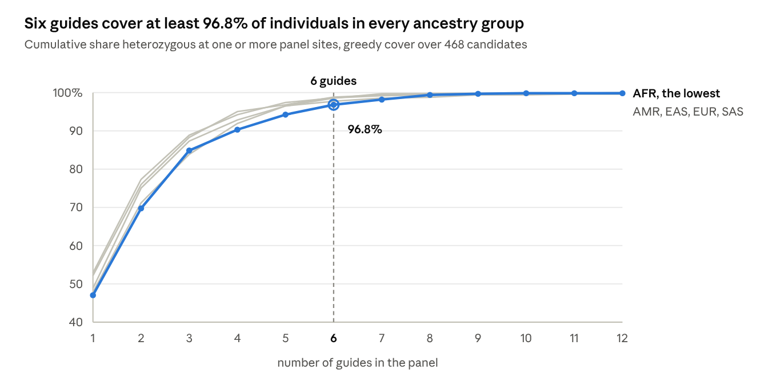
Figure 4 · greedy cover over 468 in-gene SpCas9 candidates, 2,504 unrelated samples
Returns fall away sharply after the sixth guide: the next six add 1.8 percentage points between them.

Tier-1 candidates
We define tier 1 as in-gene SpCas9 PAM-altering variants exceeding 30% observed heterozygosity in all five superpopulations — sites usable without ancestry stratification. There are 85.
rsID | GRCh37 | GRCh38 | Change | Het, all | Het, EUR | Worst ancestry | Effect
rs648411 | 16,744,500 | 16,744,269 | G>C | 49.7% | 52.9% | 47.0% | destroys
rs6907320 | 16,734,211 | 16,733,980 | C>T | 49.2% | 50.1% | 46.2% | destroys
rs9367921 | 16,634,557 | 16,634,326 | T>C | 48.4% | 52.3% | 45.2% | creates
rs3793104 | 16,681,393 | 16,681,162 | G>C | 48.0% | 51.3% | 44.5% | destroys
rs1150626 | 16,715,404 | 16,715,173 | C>T | 47.9% | 51.3% | 44.4% | destroys
rs1150628 | 16,717,216 | 16,716,985 | A>G | 47.9% | 51.7% | 43.8% | creates
rs1008252 | 16,727,083 | 16,726,852 | T>C | 47.5% | 51.7% | 44.4% | creates
rs707847 | 16,712,608 | 16,712,377 | A>G | 47.0% | 51.5% | 44.4% | creates
rs531089 | 16,706,041 | 16,705,810 | T>C | 47.0% | 47.9% | 43.6% | creates
rs56275358 | 16,704,052 | 16,703,821 | A>G | 45.8% | 55.1% | 39.7% | creates
The ten highest-ranked tier-1 sites by worst-case ancestry heterozygosity, except rs56275358, included as the single most heterozygous site in European-ancestry individuals. Both create and destroy directions are usable; which is favourable for a given patient depends on phase. The full 85-site table and the complete 24,701-variant atlas accompany this manuscript.
Candidate sites are distributed across the locus rather than clustered near the repeat: 269 of the 468 lie 200–500 kb away, with higher median heterozygosity (25.0%) than the 47 within 25 kb (18.8%). This matters for the founder analysis that follows, because a founder effect constrains haplotypes near the repeat while recombination erodes that constraint at distance.

Robustness to founder structure
The obvious objection to the preceding numbers is that they come from general-population chromosomes, whereas SCA1 expansions might sit on a restricted set of ancestral haplotypes, concentrating disease chromosomes onto backgrounds that resist discrimination. This objection does not hold at ATXN1, for two independent reasons.

The published record shows heterogeneity, not concentration
Multiple independent origins of the ATXN1 expansion are established. Every study that searched for a single founder haplotype found several: three distinct haplotypes across six South African Western Cape families [13]; four different D6S89 alleles in four French families [14]; one haplotype in five of eight Italian kindreds [15]. In the two largest marker-based analyses, concordance is partial — a two-marker haplotype in 46 of 134 Polish probands (34%) [16], and the C-4-C haplotype in ~44% of 37 Indian families [17]. In Yakutia, which has the world's highest recorded SCA1 prevalence, the entire molecular founder evidence is two markers in seven families, with an allele switch at D6S89 in two of them [18].
No SCA1 haplotype anywhere approaches the ~95% concentration of expanded European HTT chromosomes on a single haplogroup [6] — the very feature that makes a small HD panel workable.
Where a founder effect is documented, moreover, it raises eligibility rather than lowering it. The published founder haplotypes are rare in controls: ~3% of non-affected Indian chromosomes [17], 3.5% of Polish controls [16]. A disease chromosome that is unusual is easier to distinguish from a randomly drawn wild-type chromosome, not harder. The concern has the wrong sign.

An adversarial founder model puts a floor under the result
Rather than rely on that argument, we measured the worst case directly. We fixed the disease chromosome to a single complete haplotype across all 468 in-gene SpCas9 PAM-altering sites, drew the wild-type chromosome from the same single population, and swept every one of the 5,008 haplotypes as a candidate founder. Fixing all 468 sites is strictly more constraining than any real founder effect, which decays with distance from the repeat; restricting the wild-type pool to one population reproduces the reduced diversity of a bottlenecked founder population.
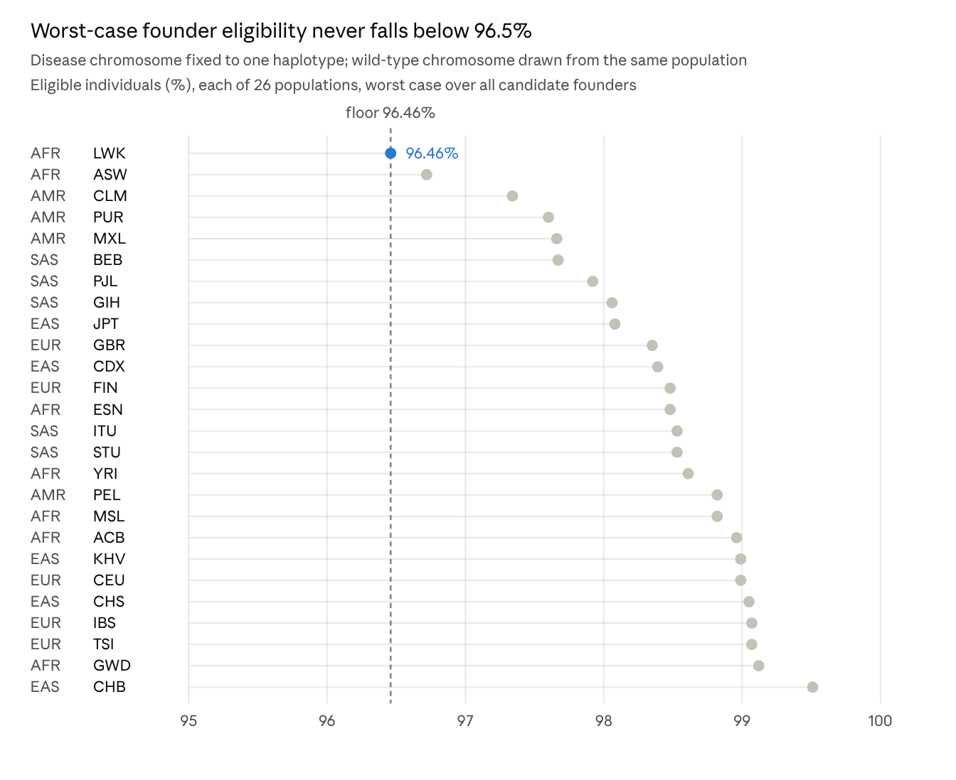
Computed from 1000 Genomes Phase 3 phased haplotypes · 26 populations, 5,008 candidate founder haplotypes, 468 in-gene SpCas9 PAM-altering sites
No population falls below 96.46%. FIN, a textbook bottleneck, gives 98.48%. At the superpopulation level the floors are higher still (98.94–99.60%), with median founders at 99.86–99.92%.

Why no founder effect can bite
The reason is haplotype uniqueness. Across 462 kb and 468 PAM-altering sites, chromosomes are very nearly individually distinguishable.
Superpopulation | Haplotypes | Distinct PAM profiles | Commonest profile
AFR | 1,322 | 1,227 | 10× (0.76%)
AMR | 694 | 644 | 4× (0.58%)
EAS | 1,008 | 986 | 3× (0.30%)
EUR | 1,006 | 960 | 3× (0.30%)
SAS | 978 | 928 | 4× (0.41%)
No profile reaches even 1% of chromosomes. There is no common background available for a founder effect to concentrate disease chromosomes onto. This is a structural property of a long, polymorphic locus, not a feature of this particular cohort, and it is the mechanistic reason the floor above is so high.

rs2075974: the one disease-associated variant is PAM-creating
The only ATXN1 variant with a published association to expanded chromosomes emerges independently from our screen as a PAM-creating site 537 bp from the repeat, with the disease-associated allele generating the PAM.
rs2075974 was identified by Mittal et al. as part of the C-4-C haplotype associated with expanded chromosomes in ~44% of Indian SCA1 families and present in only ~3% of non-affected chromosomes; the same study found the C allele enriched on both large-normal and expanded alleles, making it the only published evidence that expansion-capable ATXN1 alleles sit on a restricted flanking background [17]. Kumaran et al. replicated the association in a south Indian village cohort [19].
Position | chr6:16,327,330 (GRCh37) / 16,327,099 (GRCh38)
Change | T>C, plus strand; NM_000332.4:c.1212A>G on the transcript
Consequence | synonymous in the principal transcript
Distance to CAG tract | 537 bp
Effect | C allele creates an NGG PAM on the minus strand (AAG → AGG)
Protospacer (C allele) | 5'-GCAACAGGCCACTCATCGTG-3'
Heterozygosity | 43.9% all; 50.8% AFR, 49.0% EAS, 47.9% SAS, 34.0% AMR, 32.6% EUR

Allele orientation
Because ATXN1 lies on the minus strand and the two source papers report alleles on different strands, the orientation required explicit resolution. Three independent anchors agree.
Source | Allele reported | Strand | Resolves to
1000 Genomes AA field | C | plus | plus-strand C
Mittal et al. [17]: "SNP1 (C/T)", "the ancestral C allele", haplotype "found in all nonhuman primates" | C | plus | plus-strand C
Kumaran et al. [19]: genotypes reported as AA, AG, GG; disease-linked allele G | G | transcript | plus-strand C
This screen: the PAM-creating allele | C | plus | plus-strand C
Mittal's descriptor is self-anchoring: a site has one ancestral allele, 1000 Genomes reports it as C on the plus strand, and the primate observation confirms its ancestry independently. Kumaran's A/G are the transcript alleles, and G complements to plus-strand C. The disease-associated allele is the PAM-creating allele — the favourable direction, placing the PAM on the expanded chromosome and leaving the normal chromosome uncuttable at that site.

Phase is fixed at this site by the association
In Kumaran's cohort, 0 of 33 SCA1 individuals were A/A homozygous, while 12 of 59 controls were [19]. No patient carried the expansion on an A chromosome. If that holds, phase at this one site is determined by the association rather than requiring a per-patient assay, and eligibility is not het × ½ but simply the probability that the patient's other chromosome carries T, i.e. 1 − freq(C).
Population | freq(C) | Eligible
AMR | 20.7% | 79.3%
EUR | 21.5% | 78.5%
SAS | 41.3% | 58.7%
AFR | 45.7% | 54.3%
EAS | 47.7% | 52.3%
All | 36.9% | 63.1%
The model is testable against the source cohort and holds. Kumaran's 59 controls give freq(C) = 50.0%, predicting 50.0% patient heterozygosity; the observed value in symptomatic patients is 8/16 = 50.0% (pre-symptomatic 6/17 = 35.3%).
Two design notes. dbSNP records a rare third allele at this position (plus-strand G); it does not create a PAM, so a chromosome carrying it is simply not cut, failing safe rather than eroding selectivity. And the Phase 3 and 30× callsets agree on freq(C) to within 0.004 here, so the estimate does not depend on low-coverage genotypes.
The direction established above is a property of the reference sequence and does not vary between populations. The association does, and rests on two Indian cohorts totalling 37 families and 33 individuals. Replication elsewhere is the single highest-value follow-up this work identifies.

Confirmation on 30× high-coverage data
Every conclusion above was derived from 1000 Genomes Phase 3, at 4–6× coverage. Repeating the analysis end to end on the 30× high-coverage callset moves nothing that matters.
The 30× NYGC release is independently sequenced at roughly five times the depth, called on GRCh38, and phased with shapeit2-duohmm using trio information where available. We restricted it to the same 2,504 unrelated samples and ran the identical code, selecting the callset with a single command-line flag.
Measure | Phase 3 (GRCh37) | 30× (GRCh38)
Biallelic SNVs analysed | 24,701 | 18,819
SpCas9 PAM-altering, full window | 9,247 | 7,044
In-gene SpCas9, het ≥ 20% | 257 | 258
In-gene SpCas9, het ≥ 30% | 170 | 170
Tier-1 sites | 85 | 86
ATXN1 PAM-altering sites, gene body | 613 | 617
HTT PAM-altering sites, gene body | 197 | 204
ATXN1 phase-agnostic eligibility, EUR | 99.80% | 99.80%
HTT phase-agnostic eligibility, EUR | 78.13% | 79.13%
Panel coverage, 6 guides | 98.00% | 97.64%
Founder floor, 26 populations | 96.46% | 96.46%
rs363099 single-site eligibility, EUR | 19.68% | 19.68%
rs2075974 eligibility, EUR | 78.53% | 78.53%
The variant count falls by 24% because the 30× callset is more stringently filtered, and what it removes is almost entirely the rare tail: at every heterozygosity threshold the conclusions rest on, the counts are unchanged or one higher. The ten highest-ranked tier-1 candidates are the same ten variants in the same order, with heterozygosities agreeing to within 0.001. The ATXN1-versus-HTT gap, which is the paper's central claim, is undisturbed.
Two incidental results are worth recording because neither was designed as a control.
The excess-heterozygosity filter removes five variants from Phase 3 and zero from the 30× callset. The mapping artefacts it exists to catch — sites whose observed heterozygosity exceeds the Hardy–Weinberg ceiling of 0.5 — are simply absent from the higher-coverage data. That is independent evidence that the filter identifies a real artefact class rather than discarding genuine variation.
The CAG tract, located from reference sequence alone and independently in each build, lands at chr6:16,327,867–16,327,953 on GRCh37 and chr6:16,327,636–16,327,722 on GRCh38 — a difference of exactly 231 bp at both ends, matching the locus offset derived from the NCBI gene record. The repeat structure recovered is identical in both: CAG×12 · CAT · CAG · CAT · CAG×14 read in gene orientation.
One practical difference affects anyone reusing the data rather than the conclusions. The 30× VCF's identifier column carries chrom:pos:ref:alt strings rather than rsIDs, so named variants must be located by position; we do so with the dbSNP-confirmed coordinates in both assemblies and verify the reference allele at each. The supplementary 30× atlas restores rsIDs by an exact join to the Phase 3 atlas on position and alleles, which recovers 86% of rows; the remainder are variants Phase 3 did not call.
We report the Phase 3 figures as primary throughout because they are the analysis the manuscript was built on, and present the 30× run as the confirmation. Both are produced by one pipeline and either can be regenerated with a single flag.

Discussion
The practical conclusion is that the obstacle to allele-selective SCA1 therapy is not the genetics of the locus. It is the absence of a phasing assay and of patient-cohort data — both tractable, neither requiring new biology.
ATXN1 turns out to be a more favourable substrate than HTT, the gene on which this entire approach was developed and validated. The reason is structural rather than fortuitous. ATXN1 spans 462 kb against HTT's 169 kb and is comparably polymorphic, so it carries roughly three times as many PAM-altering sites spread over more recombination distance. Two chromosomes drawn from any population differ somewhere useful almost without exception.
That same property disposes of the founder objection. The HD field could build small target panels precisely because expanded HTT chromosomes concentrate on one haplogroup [6]; the concentration that makes a panel efficient is also what would make a locus resistant to discrimination if the disease haplotype happened to be common. At ATXN1 no haplotype profile reaches 1% of chromosomes, so neither effect operates. A founder effect cannot concentrate disease chromosomes onto a background that is not there, and where SCA1 founder haplotypes are documented they are rare in controls, which helps rather than hurts. We note that the published SCA1 founder literature is thin — eight studies, mostly 1990s microsatellite work — so our conclusion rests primarily on the measured floor rather than on that literature.
The case for pursuing selectivity at all has strengthened independently. Non-selective ATXN1 lowering is the strategy in clinical development, and the mouse genetics indicate the wild-type allele is protective [2] while the unbiased genomic analysis ranks ATXN1 among the polyglutamine genes least tolerant of knockdown [3]. Meanwhile the discrimination axis the clinical-stage agent relies on is the one documented to work least well at this gene [4]. A SNP-based axis is orthogonal to both problems.
rs2075974 deserves separate emphasis. That the one variant with published disease-chromosome evidence is also PAM-creating, 537 bp from the repeat, in the favourable orientation, is a convergence we did not anticipate and did not select for — it emerged from an unbiased screen and was only afterwards matched to the literature. If the Indian association generalises, a single guide would serve roughly 78% of European-ancestry patients with phase known a priori, which would exceed every published HTT single-site figure. That conditional is doing real work, and testing it requires only two SNP assays and a repeat sizing on an existing SCA1 cohort.

Priorities
- Replicate the rs2075974 association outside India. Determines whether SCA1 needs per-patient phasing at all. Smallest experiment, largest consequence.
- Develop the long-read phasing assay. The HTT protocol — multiplex nanopore sequencing across a 10.4 kb window, whose authors explicitly invite extension to other repeat diseases [20] — transfers directly; the window would span the candidate sites and the CAG tract on single molecules.
- Experimentally validate the top tier-1 guides for on-target activity and allele discrimination in patient-derived cells.
- Extend to ASO and siRNA chemistries. This analysis is PAM-centred and therefore CRISPR-centred; oligonucleotide discrimination depends on binding energetics rather than an absolute motif requirement, so the usable site set is larger and differently ranked.
We also note one unpublished competing effort: an Ataxia UK-funded project at Ferrara states an intention to exploit ATXN1 SNPs for personalised editing. It has no publications, and the group's published SCA1 CRISPR work is explicitly non-allele-selective [21].

Limitations
This is a resource, not a validated therapeutic target set. No guide reported here has been tested in cells. We report candidate sites and population-level eligibility; on-target activity, editing efficiency and allele discrimination all require experimental work.
Phase is unresolved for 467 of the 468 candidate sites. Knowing a patient is heterozygous does not reveal which chromosome carries the expansion, and population data cannot supply that. Every eligibility figure here except the rs2075974 estimate is constructed to be honest about this: the phase-agnostic measure assumes nothing about phase, and single-site estimates apply the ½ factor. Assigning a specific guide to a specific patient requires a long-read assay reading the variant and the CAG tract on one molecule [20].
The rs2075974 association rests on two Indian cohorts — 37 families [17] and 33 individuals from one village [19]. Mittal's 44% figure describes the three-marker C-4-C haplotype rather than the C allele alone, and neither study reports freq(C) on expanded chromosomes directly. "The expansion always sits on C" is strongly suggested, not established. The 52–79% eligibility estimates are conditional on it.
We analyse general-population chromosomes, not patient chromosomes. No public cohort of phased expanded ATXN1 chromosomes exists. The HTT work drew on thousands of patient haplotypes [7]; nothing comparable is available here, and this constraint applies to every prior attempt at this analysis as well.
The primary genotypes are 1000 Genomes Phase 3, at 4–6× coverage — but this is no longer an open caveat. The full analysis was repeated on the independently sequenced 30× high-coverage callset on GRCh38, and every conclusion held: tier-1 sites 85 → 86, phase-agnostic eligibility in European-ancestry individuals 99.80% → 99.80%, founder floor 96.46% → 96.46%. What remains is that neither callset is a patient cohort.
No off-target assessment was performed. Candidate protospacers have not been screened genome-wide for off-target sites, which is required before any guide is prioritised experimentally.
The analysis is PAM-centred. It identifies sites where a nuclease can or cannot cut, which is the strictest form of selectivity but not the only one. ASO and siRNA approaches discriminate on hybridisation thermodynamics and would admit a larger, differently ranked set of sites.
Superpopulation labels are coarse. 1000 Genomes groupings approximate but do not capture the ancestry of any individual patient, and eligibility for an admixed individual is not well predicted by a single group's figure.
Four variants were excluded as artefacts on the basis of heterozygosity exceeding the Hardy–Weinberg maximum. This filter is principled but conservative; genuine variants in segmental duplications would be removed along with mapping artefacts.

Methods

Data
Genotypes, primary analysis: 1000 Genomes Phase 3 integrated callset (ALL.chr6.phase3_shapeit2_mvncall_integrated_v5a.20130502.genotypes.vcf.gz, and the chr4 equivalent for HTT), SHAPEIT2-phased, on GRCh37.
Genotypes, confirmatory analysis: the 1000 Genomes 30× high-coverage release (CCDG_14151_B01_GRM_WGS_2020-08-05_chr{6,4}.filtered.shapeit2-duohmm-phased.vcf.gz, NYGC), phased with shapeit2-duohmm, on GRCh38, obtained from the EBI FTP site. The AWS S3 mirror of this release contains zero-byte placeholder objects and must not be used.
Both callsets were restricted to the same 2,504 unrelated samples listed in integrated_call_samples_v3.20130502.ALL.panel (AFR 661, AMR 347, EAS 504, EUR 503, SAS 489), giving 5,008 haplotypes; the 30× VCF additionally contains 698 related samples, which are excluded by that intersection. The pipeline aborts if the intersection is not exactly 2,504.
Gene coordinates: NCBI Gene, ATXN1 (GeneID 6310) chr6:16,299,343–16,761,691 on GRCh37.p13 (NC_000006.11) and chr6:16,299,112–16,761,460 on GRCh38.p14 (NC_000006.12); HTT (GeneID 3064) chr4:3,076,408–3,245,687 and chr4:3,074,681–3,243,960 respectively. Both genes are 462,349 bp and 169,280 bp in both builds, so the inter-build difference is a constant offset — −231 bp at ATXN1, −1,727 bp at HTT. The pipeline asserts at load that each offset is identical at both gene termini, so a mistyped coordinate fails immediately rather than silently shifting the atlas; both offsets were additionally confirmed against dbSNP records for rs2075974 and rs363099. Positions are reported in both assemblies throughout, the analysed callset supplying the real values.
Reference sequence: retrieved from NCBI E-utilities over each analysis window — NC_000006.11 and NC_000004.11 for the GRCh37 analysis, NC_000006.12 and NC_000004.12 for the GRCh38 confirmation — with 50 bp of padding so that PAM windows at the window edges are complete.

Variant selection
Within chr6:16,099,343–16,961,691 we retained records that were biallelic, single-nucleotide in both alleles, with both alleles in {A,C,G,T}, and not excluded by the VT field. We then removed sites with observed heterozygosity > 0.55, which exceeds the Hardy–Weinberg maximum of 0.5 and indicates collapsed paralogous mapping, and sites with excess-heterozygosity z > 8, where z = (H_obs − 2pq) / SE and SE is the binomial standard error of 2pq at the sample size. Four and one sites respectively were removed, leaving 24,701.
As a positive control on coordinates and strand, every retained REF allele was compared against the retrieved reference; agreement was 24,701/24,701.

PAM screening
For a variant at reference index i and a motif of length L, we enumerated all windows [s, s+L−1] with s ∈ [i−L+1, i], i.e. every placement overlapping the variant. For each window we tested the motif against the forward sequence and against its reverse complement, under IUPAC expansion (N = ACGT, R = AG, V = ACG). Motifs: SpCas9 NGG, SaCas9 NNGRRT, xCas9/SpCas9-NG NG, Cas12a TTTV. A variant was scored as creating a PAM where a (strand, position) pair matched under the alternative allele but not the reference, and destroying one in the converse case. A single variant may do both.

Eligibility measures
Observed heterozygosity is the fraction of individuals with non-identical alleles, computed overall and per superpopulation.
Single-site eligibility is observed heterozygosity × P(the PAM-bearing allele lies on the expanded chromosome), taken as 0.5 absent independent information.
Phase-agnostic eligibility. Let P[i,h] = 1 where haplotype h carries the PAM-bearing allele at site i — the alternative allele where the variant creates a PAM, the reference allele where it destroys one. An individual is counted eligible when both of their haplotypes are independently targetable: there exists a heterozygous site at which haplotype 1 carries the PAM-bearing allele, and a heterozygous site at which haplotype 2 does. A selective guide then exists whichever haplotype carries the expansion.
Guide panel. Greedy set cover over the 468 in-gene SpCas9 PAM-altering sites with heterozygosity ≥ 5%: at each step select the site adding the most uncovered individuals, where covered means heterozygous at a selected site.
Founder model. For a candidate founder haplotype f and a wild-type haplotype c drawn from the same group, the pair is eligible if ∃i: P[i,f] = 1 and P[i,c] = 0 — equivalently, c fails only if it carries a PAM at every site where f does. Eligibility(f) is the fraction of c in the pool that succeed. We swept all haplotypes as f, first with both f and the pool drawn from each of the five superpopulations, then from each of the 26 populations. Haplotypes with no PAM-bearing allele at any site score 0 by definition; none occurred.

Software
Python 3.13, pysam 0.24.1, NumPy 2.5.3, pandas 3.0.5. All analysis ran on a single machine in approximately four minutes of compute.

Data and code availability
All inputs are publicly downloadable without credentials or data-use agreements. Analysis scripts, unit tests and a verifier that checks the output against the values reported here are provided as a single package; --build phase3 reproduces the primary analysis and --build grch38_30x the confirmation, and compare_builds.py prints the side-by-side difference. Supplementary data files: ATXN1_allele_selective_atlas_v0.csv.gz (24,701 variants, both-build coordinates, per-ancestry heterozygosity, per-nuclease PAM annotations), ATXN1_tier1_candidates.csv (85 sites), founder_worstcase_by_population.csv (26 populations), and the 30× equivalents (18,819 variants; 86 tier-1 sites), with rsIDs restored by exact join. All data and code are deposited at https://github.com/sadaszewski/allele-selective-target-site-atlas-for-atxn1.

Figures and tables
Figure 1. The 468 in-gene SpCas9 PAM-altering candidate sites by position and observed heterozygosity, across the 462 kb of ATXN1 (GRCh37). The CAG tract at chr6:16,327,867–16,327,953 is marked, as is rs2075974, 537 bp from it. 257 of the 468 sites are at least 20% heterozygous, and they are distributed across the locus rather than clustered near the repeat (included above).
Figure 2. The two discrimination axes. (A) At rs2075974 the expanded chromosome carries C, which completes an NGG PAM on the minus strand and is cut; the normal chromosome carries T, has no PAM, and cannot be cut. (B) Repeat length at representative allele sizes: the expanded ATXN1 tract is 1.5× the normal one, against 2.6× at HTT, which is why repeat-directed discrimination fails here (included above).
Figure 3. Worst-case founder eligibility across all 26 populations (included above).
Figure 4. Cumulative coverage of the greedy guide panel by superpopulation, for panels of one to twelve guides. Coverage is the share of individuals heterozygous at one or more selected sites. AFR, the lowest group throughout, reaches 96.8% at six guides; the next six guides add 1.8 percentage points between them (included above).
Table 1. PAM-altering variant counts by nuclease (above).
Table 2. ATXN1 versus HTT on identical method (above).
Table 3. Tier-1 candidate sites, top ten of 85 (above); full table as Supplementary Table S1.
Table 4. rs2075974 allele orientation across sources (above).
Table 5. Phase 3 versus 30× on identical method (above).
Supplementary Table S1. All 85 tier-1 candidates. Supplementary Table S2. The complete atlas, 24,701 variants. Supplementary Table S3. Founder worst-case eligibility for each of the 26 populations. Supplementary Table S4. The 30× GRCh38 atlas, 18,819 variants, with rsIDs restored by exact join to Supplementary Table S2. Supplementary Table S5. The 86 tier-1 candidates called on the 30× callset.

References
- Orr HT, Chung MY, Banfi S, et al. Expansion of an unstable trinucleotide CAG repeat in spinocerebellar ataxia type 1. Nat Genet. 1993;4:221–226. PMID 8358429.
- Nitschke L, Coffin SL, Xhako E, et al. Modulation of ATXN1 S776 phosphorylation reveals the importance of allele-specific targeting in SCA1. JCI Insight. 2021;6(3):e144955. PMID 33554954.
- Namuli KL, Drögemöller BI, Wright GEB. Unbiased human genomic characterization of polyglutamine disorder genes to guide biological understanding and therapeutic strategies. HGG Adv. 2026;7(1):100547. PMID 41254939.
- Hu J, Corey DR. Limits of using oligonucleotides for allele-selective inhibition at trinucleotide repeat sequences — targeting the CAG repeat within ataxin-1. Nucleosides Nucleotides Nucleic Acids. 2020;39(1–3):185–194. PMID 31645175.
- Christie KA, Courtney DG, DeDionisio LA, et al. Towards personalised allele-specific CRISPR gene editing to treat autosomal dominant disorders. Sci Rep. 2017;7:16174. PMID 29170458.
- Warby SC, Montpetit A, Hayden AR, et al. CAG expansion in the Huntington disease gene is associated with a specific and targetable predisposing haplogroup. Am J Hum Genet. 2009;84:351–366. PMID 19249009.
- Kay C, Collins JA, Skotte NH, et al. Huntingtin haplotypes provide prioritized target panels for allele-specific silencing in Huntington disease patients of European ancestry. Mol Ther. 2015;23:1759–1771. PMID 26201449.
- Shin JW, Hong EP, Park SS, et al. PAM-altering SNP-based allele-specific CRISPR-Cas9 therapeutic strategies for Huntington's disease. Mol Ther Methods Clin Dev. 2022;26:547–561. PMID 36092363.
- Shin JW, Hong EP, Park SS, et al. Allele-specific silencing of the gain-of-function mutation in Huntington's disease using CRISPR/Cas9. JCI Insight. 2022;7(19):e141042. PMID 36040815.
- Keough KC, Lyalina S, Olvera MP, et al. AlleleAnalyzer: a tool for personalized and allele-specific sgRNA design. Genome Biol. 2019;20(1):167. PMID 31416467.
- Kerkhof LMC, van de Warrenburg BPC, van Roon-Mom WMC, Buijsen RAM. Therapeutic strategies for spinocerebellar ataxia type 1. Biomolecules. 2023;13(5):788. PMID 37238658.
- Chung MY, Ranum LP, Duvick LA, et al. Evidence for a mechanism predisposing to intergenerational CAG repeat instability in spinocerebellar ataxia type I. Nat Genet. 1993;5:254–258. PMID 8275090.
- Ramesar RS, Bardien S, Beighton P, Bryer A. Expanded CAG repeats in spinocerebellar ataxia (SCA1) segregate with distinct haplotypes in South African families. Hum Genet. 1997;100:131–137. PMID 9225982.
- Khati C, Stevanin G, Durr A, et al. Genetic heterogeneity of autosomal dominant cerebellar ataxia type 1. Neurology. 1993;43:1131–1137. PMID 8170557.
- Jodice C, Frontali M, Persichetti F, et al. The gene for spinal cerebellar ataxia 1 (SCA1) is flanked by two closely linked highly polymorphic microsatellite loci. Hum Mol Genet. 1993;2:1383–1387. PMID 8242061.
- Krysa W, Sulek A, Rakowicz M, Szirkowiec W, Zaremba J. High relative frequency of SCA1 in Poland reflecting a potential founder effect. Neurol Sci. 2016;37:1319–1325. PMID 27193757.
- Mittal U, Sharma S, Chopra R, et al. Insights into the mutational history and prevalence of SCA1 in the Indian population through anchored polymorphisms. Hum Genet. 2005;118:107–114. PMID 16133185.
- Lunkes A, Goldfarb LG, Platonov FA, et al. Autosomal dominant spinocerebellar ataxia (SCA) in a Siberian founder population: assignment to the SCA1 locus. Exp Neurol. 1994;126:310–312. PMID 7925830.
- Kumaran D, Balagopal K, Tharmaraj RG, et al. Genetic characterization of spinocerebellar ataxia 1 in a South Indian cohort. BMC Med Genet. 2014;15:114. PMID 25344417.
- Fang L, Monteys AM, Dürr A, et al. Haplotyping SNPs for allele-specific gene editing of the expanded huntingtin allele using long-read sequencing. HGG Adv. 2023;4(1):100146. PMID 36262216.
- Pappadà M, Bonuccelli O, Buratto M, et al. Suppressing gain-of-function proteins via CRISPR/Cas9 system in SCA1 cells. Sci Rep. 2022;12:20285. PMID 36434031.

